Corner Grocer Item-Tracking Program

In this project, I designed and implemented a C++ program for the Corner Grocer that analyzes grocery purchase records and reports how often each item is purchased. The goal of this program is to help the store rearrange its produce section based on item frequency. The program reads a text file named CS210_Project_Three_Input_File.txt, where each word represents an item purchased during the day, and then provides a menu-driven interface so the user can explore the data.

I organized the core logic of the program into a class called GroceryTracker. This class uses a private map<string, int> data member to store each unique item and its total frequency. The class constructor accepts two file names: the input file and the backup file. When the object is created, it automatically calls a private LoadDataFromFile function to read the input file and populate the map. It then calls another private function, WriteFrequencyFile, which writes all item names and their counts to a backup file called frequency.dat. This design keeps file handling and data processing together in one place, which improves readability and maintainability.
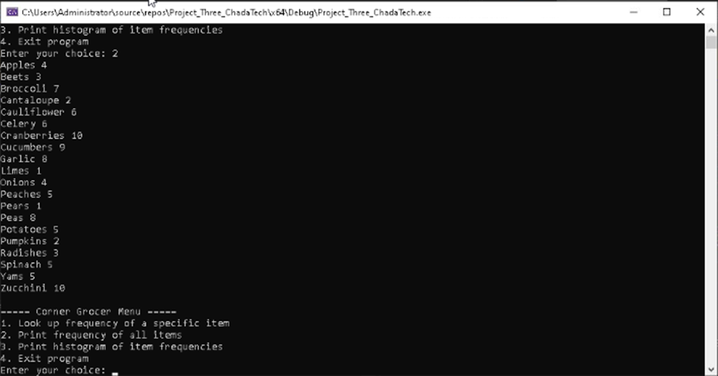

The GroceryTracker class also provides several public member functions that support the menu options. The GetItemFrequency function returns the frequency of a specific item, or zero if the item is not found. This function is used by menu option one, where the user types an item name and the program prints how many times it appears in the input file. The PrintAllFrequencies function prints every item and its frequency on separate lines, which satisfies menu option two. For menu option three, the PrintHistogram function prints each item followed by a number of asterisks that matches the frequency value, creating a simple text-based histogram.
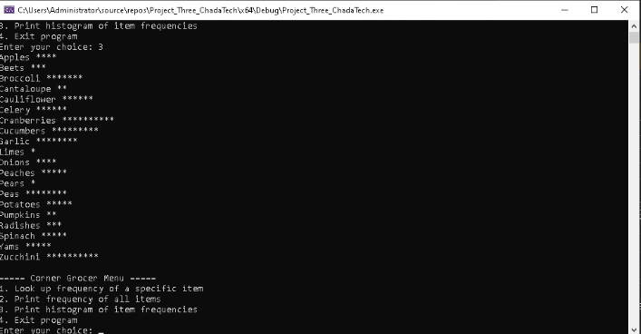
In the main function, I created a GroceryTracker object and then implemented a loop that displays a menu with four options. The program uses standard input validation to make sure the user enters a numeric menu choice. If the user chooses option one, the program prompts for an item name and calls GetItemFrequency. If the user chooses option two or three, the program calls PrintAllFrequencies or PrintHistogram respectively. Option four exits the loop and closes the program. Throughout the code, I used clear variable names, in-line comments, and consistent formatting to follow industry best practices. This project helped me practice using classes, maps, file input and output, and menu-driven design in C++.

